Name : Shrikrushna Santosh Zirape

Roll No : 31284

LP-2 Mini Project Report

**Library Management System**

**Aim**: To develop a Library Management System for on-campus Library. The program should be able to calculate the no of books available, fine(if any), no of books borrowed by one student.

**Description:** Students borrow books from the Library. Sometimes they fail to return the book within the stipulated amount of time. In such cases, they should be fines for the late return. Sometimes due to a high demand, the students should know what is the approximate date when a certain book will be available.

We have implemented Library Management system which calculates the no of copies of a certain books available, and how many books has a certain student borrowed.

## Table Description:

Following are the tables along with constraints used in *Library Management* database.

1. **MEMBERS**: This table includes details of the members who have a library subscription. This table includes details like designation, roll number, name, mobile number, address, pincode.

*Constraint*: Mobile number should be 10 digits and pincode should be 6 digits. Roll number should be unique

1. **BOOKS**: This table contains the details of books available. The details of books included in the table are Book name, author, No. of copies, Publisher, etc

*Constraint*: Book id should be unique.

**Relational Database Schema for Case Study**

The relational database schema for *Hospital Management* database is as follows:

1. Members (designation, roll number, name, mobile number, address, pincode)
2. Books (Book name, author, No. of copies, Publisher)

Graphical User Interface, Source Code

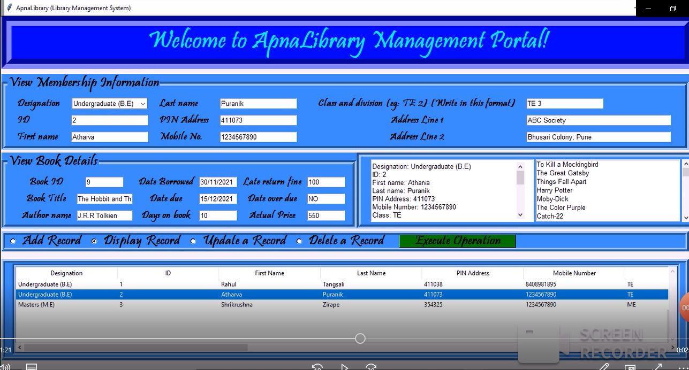

### ER DIAGRAM

### 

### Library Management System Test cases

### In colleges, where students frequently borrow books, the library management system can be used to keep a track of which student has borrowed what book

### The library management system can be used to find the pending fine for a particular student.

### Find the no of books available at a given point of time and their expected date of return.

Conclusion

Implementation of library management system project helps to store all the details in a concise and proper way. It makes the functioning of the library smoother. It prevents confusion and helps maintain a proper track of things.